Bar chart

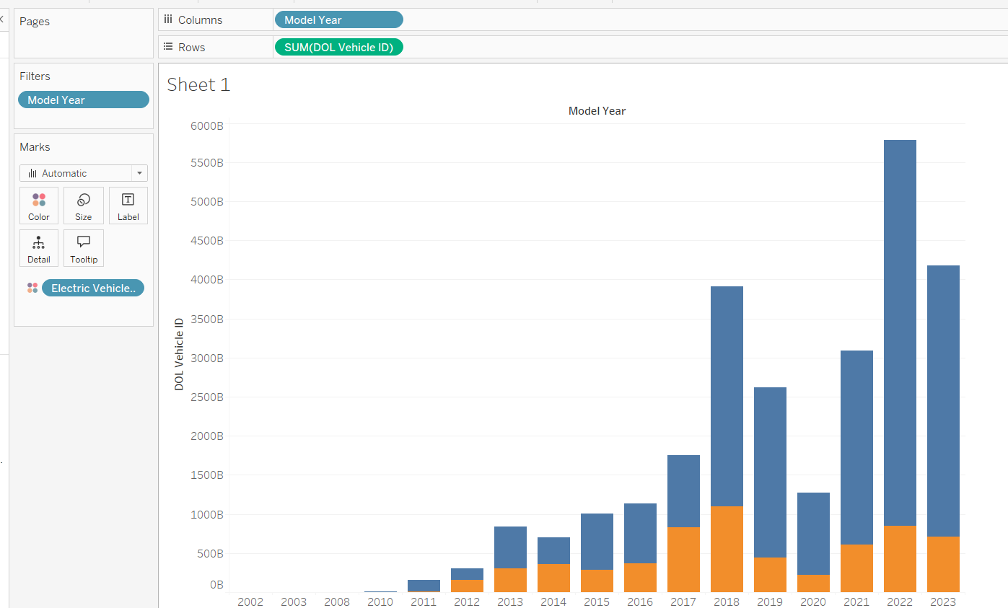

In order to hide the labels we right click the bar chart and then we click on the show labels bar, so inside the bar chart we will get the values

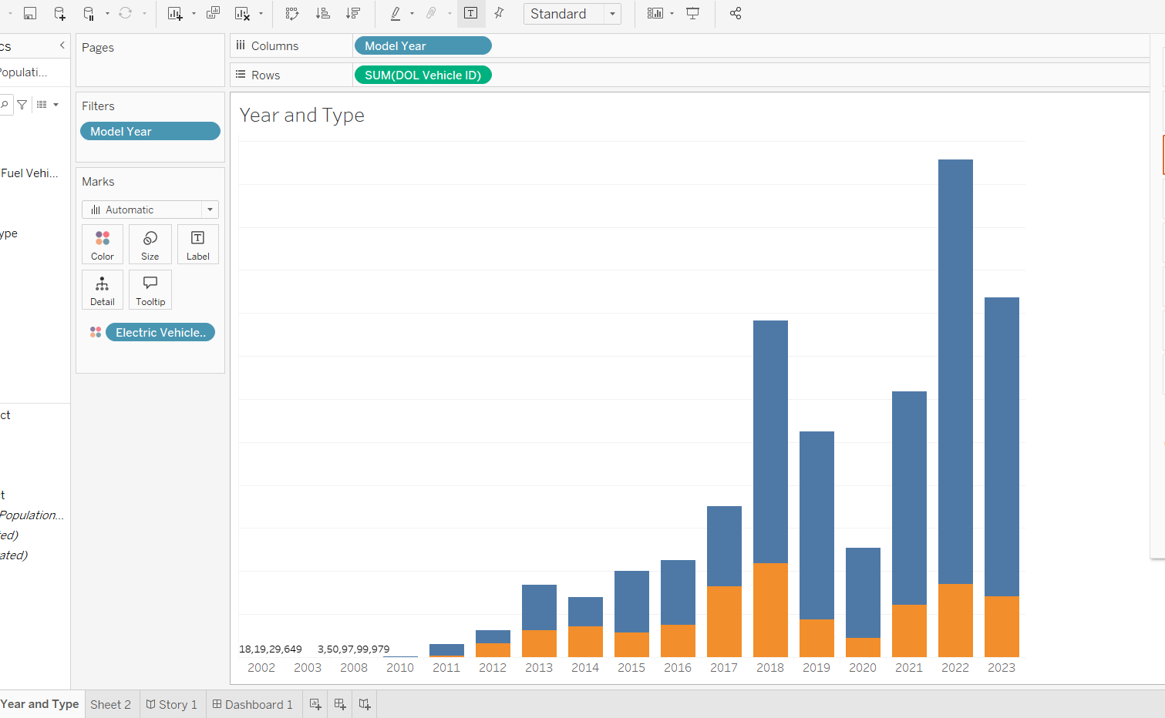  
  
this picture will tell you at which year how many electric vehicles were sold,   
yellow -> electric vehicles

Blue -> normal vehicle

3. Creating a Map

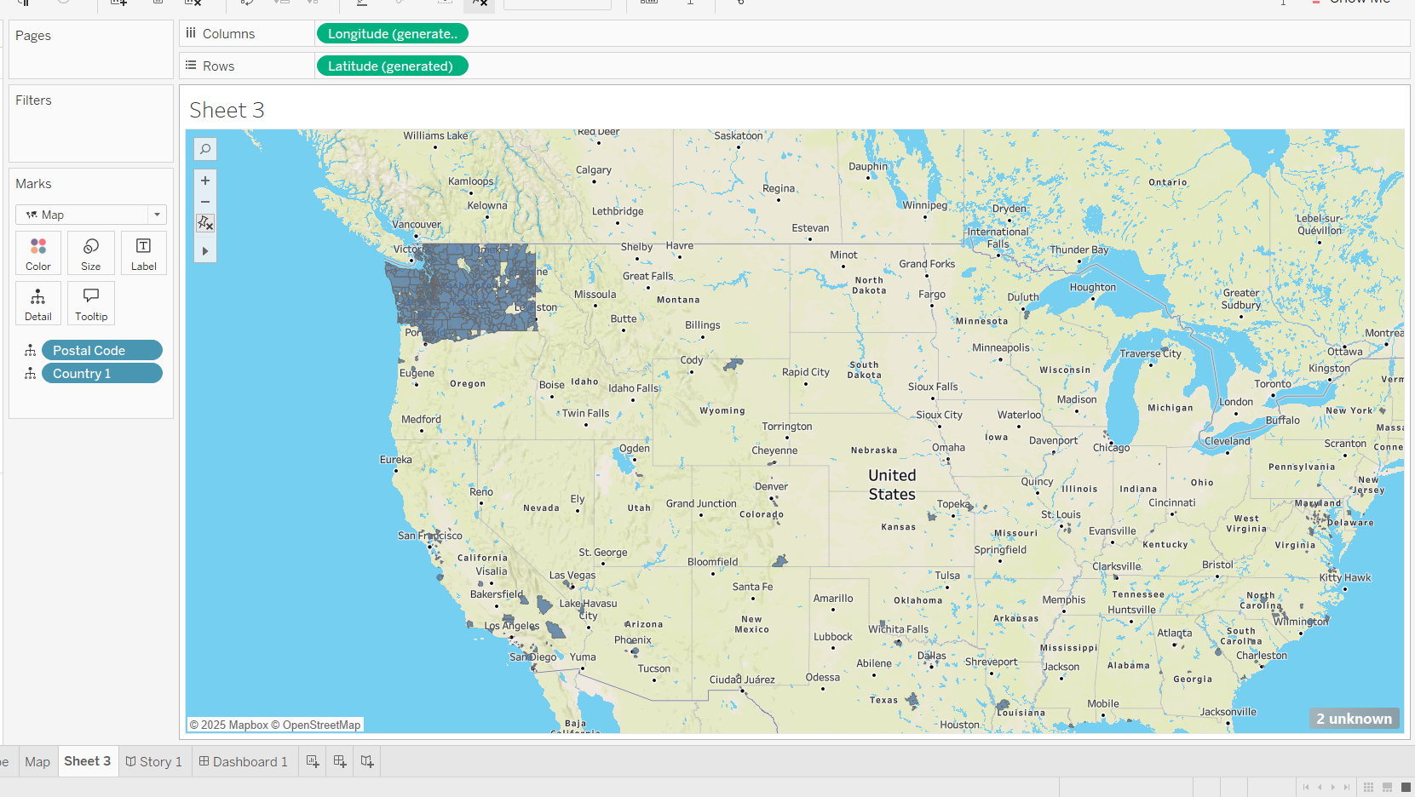  
  
now I have created a visualization map for postal code and have created a field called country1 , it consist of all the values of the columns country states .

Top 10countries

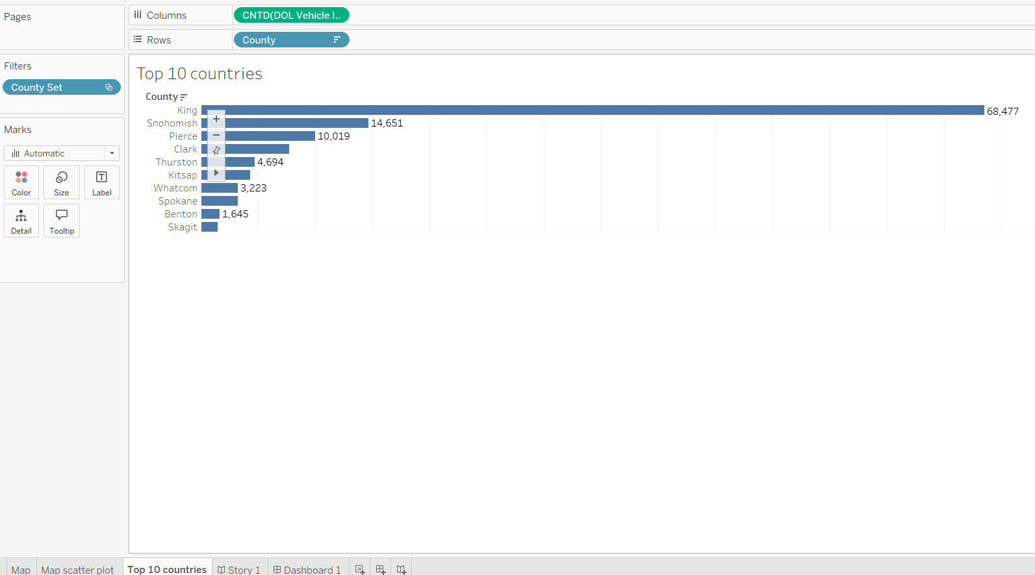

Here wjat we did means, we kept the county in rows and dol vehicle in the columns, then we kept the filter as top 10 in the field and the I have labe as true, so we are getting this top values

Make and Model

Next we are joining two columns that is make and model

Using the create hierarchy option.

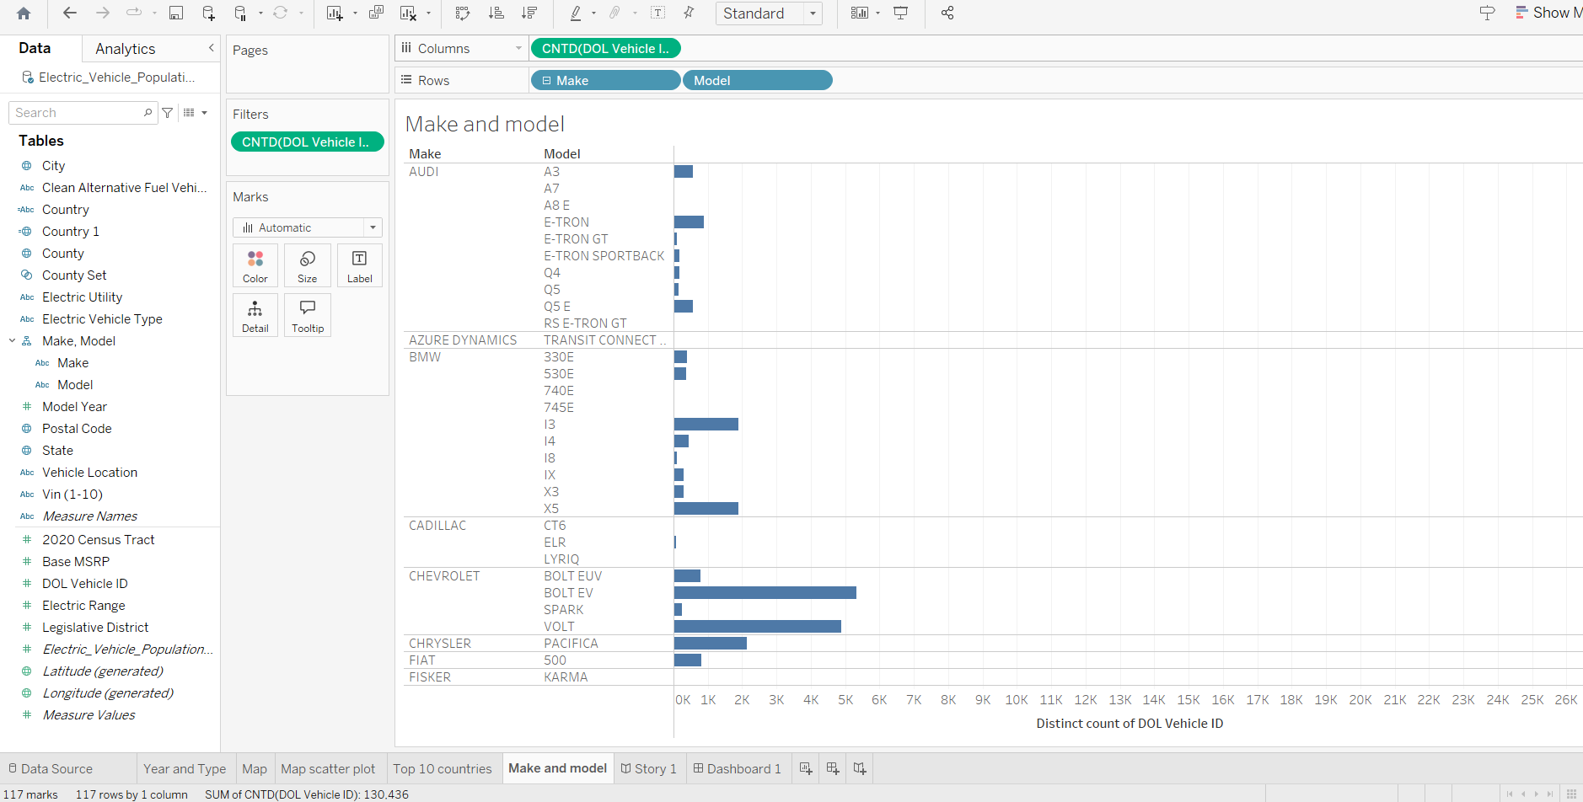

Filter option is present in all the fields horizontal or vertical values

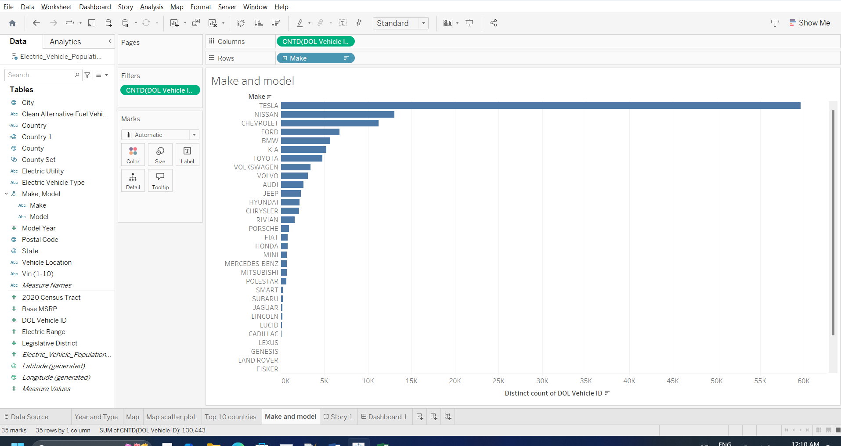

Donut chart

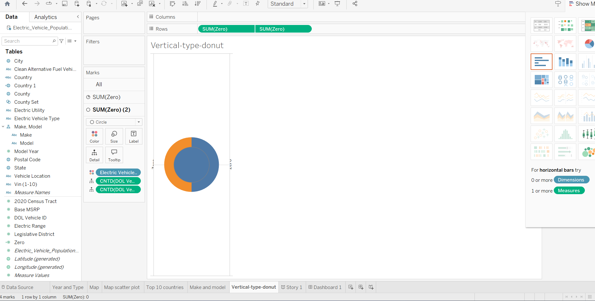

Final Dashboard preparation

